Chapter 3, Solution 36

Use mesh analysis to obtain i₁ , i₂, and i₃ in the circuit in Fig. 3.84.

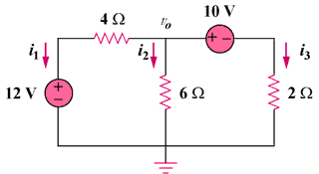

Figure 3.84
For Prob. 3.36.

Solution

I₁

I₂
–
+

12 V
+ –

10 V

4 Ω

6 Ω

2 Ω

i₃

i₂

i₁

Applying mesh analysis gives,

10I₁ – 6I₂ = 12 and –6I₁ + 8I₂ = –10

or

I₁ = (24–15)/11 = 0.8182 and I₂ = (18–25)/11 = –0.6364

i₁ = –I₁ = –818.2 mA; i₂ = I₁ – I₂ = 0.8182+0.6364 = 1.4546 A; and
i₃ = I₂ = –636.4 mA.

